427
Effects of Light Intensity on Growth of Some Tropical Forage Species.
I. Interaction of Light Intensity and Nitrogen Fertilization on Six Forage Grasses¹
F. I. Eriksen and A. S. Whitney²
ABSTRACT
In order to determine the response of some tropical grass species to low light situations such as under plantation crops, seasonal cloud cover, etc., six tropical forage grasses were evaluated over a 20 month period on an Oxic Haplustoll in Hawaii (100 m above sea level) under four light regimes (100, 70, 45, and 27⁰/, daylight using polypropylene netting) in the field.
The forage grasses evaluated were: Brachiaria brizantha, B. miliifirmis, Digitaria decumbens, Panicum maximum, Pennisetum clandestinum, and P. purpureum. Dry matter yields of N-fertilized (865 kg N ha⁻' yr⁻¹) grasses were highest at 100 and 70% daylight (16 to 40 metric tons of dry matter (DM) ha⁻' yr⁻¹), with P. maximum and P. purpureum having highest yields. Under 277, daylight, yields were 8 to 15 tons, with P. maximum, B. brizantha, and B. miliiformis having highest yields. When no N was added maximum yields in tons ha⁻' yr⁻' were B. mWiformis, 9.2 at 27% daylight; D. decumbens, P. maximum, and B. brizantha, 18.5 to 15.0 at 45% daylight; and P. clandestinum, 9.2 at 70% daylight. P. purpureum without N yielded 30 tons at full daylight, apparently because its very extensive root system invaded adjacent N-fertilized plots. Percentage of DM in the forage decreased with shading and N fertilization. Percent N increased with decreasing light intensity (from 1.0 to 1.6% in the minus-N and from 1.2 to 1.9% in the plus-N treatments). Slight acetylene reduction activity was found in soil cores beneath all species, except B. brizantha, indicating that the plants were almost entirely dependent on soil and fertilizer N for growth. Sward height increased significantly with decreasing light intensity and N fertilization. Concentrations of P, K, Ca, Mg, S, Cu, and Zu tended to be higher in shaded forage, higher in N-fertilized forage (except for P and Zn), and generally higher during the cool season.
Thus under N-deficient conditions, most yield and forage quality parameters were enhanced under moderate shade. Conversely, the tropical grasses studied generally responded to N fertilization only under conditions of moderate to high solar radiation.
Root weight data and observations on the rate of recovery after clipping indicate the shaded pastures would require careful management to avoid excessive depletion of root reserves, either by lenient grazing to maintain high leaf areas or by allowing an extended recovery period.

Additional index words: Shading, Acetylene reduction, N-fixation, N percentage, Root weight, Dry matter content, Height, LAI, Brachiaria brizantha, Brachiaria mitiiformis, Digitaria decumbens, Panicum maximton, Penxisetum cfandestiuuan, Penniwtum purpuretan.

THE climate of tropical areas is characterized by intense year-round solar radiation above the atmosphere. However, during the wet season, solar radiation re aching the earth's surface may be quite low due to dense cloud cover. In Hawaii, solar radiation in different areas varies from 429 to 704 cal cm⁻2 day⁻¹ in June and from 244 to 426 cal cm⁻² day⁻' in December (Yoshihara and Ekern, 1977). In many areas where tree crops are grown (e.g., coconut, oil palm, timber, firewood, or rubber trees), forage crops and pastures may be grown in the partial shade of these trees, especially during the first few years. Thus it is often
necessary to grow forage grasses under low-light conditions in the tropics.
Decreased dry matter (DM) production under reduced light intensity has been found with many grass and legume species (Blackman and Templeman, 1938; Burton et al., 1959; Deinum, 1966; Ludlow et al., 1974), but the magnitude of the effect on growth depends on the stage of growth and on concurrent temperature, moisture, and nutrient (especially N) stresses.
Positive interactions between light intensity and N application have been reported for several temperate grasses (Blackman and Templeman, 1938; Burton et al., 1959; Deinum, 1966). For example, Blackman and Templeman (1938) reported that shading to 61 and 44% of daylight did not affect the yield of Agrostis tenuis Sibth and Festuca rubra L. at low N fertilization. When N fertilizer was added, the yield increased dramatically in normal daylight, but not in shade. Deinum (1966) reported that DM and N yields were higher at reduced light intensities (100 cal cm⁻² day⁻') when N was deficient. However, when yields of stubble and roots were included, total yields were equal at all light intensities, since the plants adapted to the lower light intensity by translocating a lower proportion of the assimilates to the roots. Increased shoot: root ratios under low light intensity have also been reported for both tropical and temperate grasses and legumes by others (Burton et al., 1959).
Shading of grasses generally causes elongated growth, reduced specific leaf weight (SLW), and increased leaf area ratio (LAR), (Earley et al., 1966; Paulsen and Smith, 1969; Ludlow et al., 1974; Pyon, 1975). Plants grown in the shade are also more succulent, resulting in a lower DM percentage (Gordon et al., 1962).
Nitrogenase activity (estimated by acetylene-reduction assay) has been measured in some rhizosphere associations in recent years (Schank and Day, 1977). However it is not known to what extent this N-fixation activity may be affected by light intensity.
The N and mineral contents (dry weight basis) of grasses usually increase with shading in contrast to the legumes which are not greatly affected in this respect (Bathurst and Mitchell, 1958; Burton et al., 1959; Gordon et al., 1962). Cunningham and Nielsen (1965) reported that total cations of several crop species
'Journal Series No. 2486 of the Hawaii Agric. Exp. Stn. This work is part o£ a dissertation presented by the senior author in partial fulfillment of the requirements for the Ph.D. degree in Agronomy at the Univ. of Hawaii and was supported jointly by the Hawaii Agric. Exp. Stn. and the USAID Contract ta-C-1207 (NifTAL Project, P. O. Box O, Paia, HI 96779). Received 12 Feb. 1980.
'Former research assistant and agronomist respectively, Dep. of Agronomy and Soil Science, University of Hawaii College of Agriculture and Human Resources, Honolulu, Hi 96822. Present address of senior author: Mailing Agricultural College, 8340 Malling, Denmark.
2
AGRONOMY JOURNAL, VOL. 73, MAY-JUNE 1981
were positively correlated with N content. Myhr and Saebo (1969) and Mayland and Grunes (1974) reported similar results.
Little work has been done on the effect of shading on tropical forage grasses and legumes. However, such studies could be very useful since there are extensive areas in the tropics where grazing could be profitably carried out under coconut palms (Hugh, 1972; Javier, 1974) and other plantation crops. Also total solar radiation is greatly reduced in many tropical areas due to seasonal cloud cover.
The experiments reported here were carried out to assess the effect of shading on the performance of six tropical grasses fertilized with N (356 kg N ha⁻¹ yr⁻¹) or given no N fertilizer.
MATERIALS AND METHODS
Six grasses were grown on an Oxic Haplustoll near Paia, Hawaii (20°55'N and 156°22'W, 100 m above sea level) during the period July 1975 to February 1977. Grasses which were replicated three times included: corigrass (Brachiaria miliiform1s (Presl.) A. Chase), Mealani hybrid digitgrass (Digitaria decumbens Stent.), and guineagrass (Panicum maximum Jacq.). Grasses which were not replicated included: signalgrass (Brachiaria brizantha Hochst. ex. A. Rich.), kikuyugrass (Pennisetum clandestinum Hochst. ex. Chiov.) and napiergrass 3418 (Pennisetum purpureum Schumach.). Each species was grown under two N levels: without N ("minus-N"), and with 365 kg N ha-¹ yr⁻¹ ("plus-N") applied as urea broadcast after each cutting (once every 8 weeks) to provide 56 kg N ha⁻¹. The plants were grown under four different light regimes: 100, 70, 45, and 27% of full daylight, by shading with three densities of polypropylene screening. The screening was stretched over the plots 1.9 m above the ground, to allow air circulation and easy passage underneath. The sides facing east and west slanted down at a 45° angle to 1 m above the ground, to shade the plants from morning and evening sun. Each shaded block measured 12.2 X 13.4 m.
Before planting, phosphate and potash were applied at a rate of 150 kg ha⁻¹ of P as treble superphosphate and 180 kg ha⁻¹ of K as muriate of potash. Lime was applied at a rate of 3,400 kg ha⁻¹ to increase the pH to about 6.3. An additional 80 kg ha⁻¹ P was applied one year later and an additional 90 kg ha⁻¹ K was applied at 6 months and 12 months after establishment.
Watering was by subsurface drip irrigation using polyethylene tubes (13 mm inside diameter) buried 15 cm deep and spaced at 90 cm intervals. Emitter spacing was varied so that treatments receiving 100, 70, 45, and 27% daylight received water in proportions of 100, 89, 72, and 50 in order to compensate for differences in evapotranspiration.
Three replications of a split-split plot arrangement were used with light regimes as whole plots, species as sub-plots, and N levels as sub-sub-plots. Each sub-sub-plot measured 2.0 X 2.6 m. The total area harvested for yield determination per plot was 2.7 m'.
Gumeagrass was established from seeds and the other grasses were established by vegetative propagation. The experiment was established on 27 July 1975, shaded 2 months later, and the speties harvested every 8 weeks during the period November 1975 to February 1977. All species were cut at 4 to 7 cm above the ground using a small sickle-bar mower, except for guineagrass (cut at 15 cm) and napiergrass (30 cm).
Measurements taken included: 1) green weight; 2) dry weight measured by drying the samples at 55 C to constant weight; 3) N content of the dried and ground samples by Kjeldahl digestion (0.5 g sample) followed by determination of NH₄ using an automatic analyzer; 4) mineral content (P, K, Ca, Mg, Si, S, Cu, Zn) for the 9 March, and 25 August harvests by X-ray fluorescence quantometer; 5) sward height measured after 8 weeks regrowth on 5 Mar. and 24 Aug. 1976; 6) area:dry weight ratio of the foliage (leaves plus stem) and leaf-plus-stem area index at the 25 Aug. 1976 and 9 Feb. 1977 harvests based on the projected area of three weighed subsamples of chopped fresh forage per lot using an optical planimeter (Davis et al., 1966, modified); 7) nitrogenase activity (measured as acetylene
reduction) of undisturbed soil cores (17 cm diameter X 20 cm depth) incubated for 24 hours with 5% acetylene (95% air) and subsequently measured for ethylene production by gas chromatography; 8) root dry weights based on a sampled soil volume of 30 x 30 cm in each plot at completion of the experiment.
Results were analyzed statistically using split-split plot analysis of variance and the Bayes L.S.D. The results from the nonreplicated species were adjusted for replication effects using the procedures for augmented designs described by Federer and Rag havarao (1975).

RESULTS AND DISCUSSION

Growing Conditions

The solar radiation in full daylight and the average daily temperature under a grass sward at 5 cm depth at noon for 100 and 27% daylight during the experimental period are shown in Fig. 1. The soil temperature under 27% daylight was between 0.8 C cool season) and 2.0 C (summer) lower than full daylight, with 45 and 70% daylight intermediate.
During summer (June through August) the shade treatments resulted in average levels of radiation (in cal cm⁻² day⁻¹) of about 660 (100% daylight), 462 (70o-% daylight), 297 (45% daylight), and 178 (27% daylight). During the cool season (December through February) these values were, respectively: 380, 266, 171, and 103.
Conditions were therefore generally suitable for growth of the species tested, although there were some seasonal variations in growth as noted in the following sections.

Dry Matter Yields
The three replicated grasses (guineagrass, Mealani digitgrass, and corigrass) all responded markedly to N application when grown at 100 or 70% daylight. Annual dry matter (DM) yields of the plus-N treatments at 100 and 70% daylight were 2.5 to 3.5 times the yield of the comparable minus-N plots (Fig. 2). At 27% daylight, however, the plus-N plots yielded
ERIKSEN & WHITNEY: LIGHT INTENSITY EFFECTS ON GROWTH
3
shade such as poor adaptation (e.g. kikuyugrass) or low N availability, maximum yields were achieved under denser shade (e.g. minus-N corigrass at 27% daylight).
The growth of the different species varied greatly with the seasons (Fig. 4). Guineagrass was the highest yielding of the three replicated species except at July harvest, when Mealani digitgrass excelled. The yields of minus-N guineagrass and corigrass under full daylight were very low during the summer months. These yield reductions may be due to the destruction of chlorophyll by sunlight at a rate faster than it could be replenished by the N stressed plants (Friend, D.J.C., personal communication). Although chlorophyll contents were not measured, this hypothesis is supported by visual observations that the leaves of the minus-N grasses grown in full daylight were very yellow, especially during the summer when radiation was more intense.
Stomatal resistance measurements were made on guineagrass (minus-N treatments) at midday, but there were no significant differences among light intensities
only 1.4 times the yield of the minus-N plots. Yields of the minus-N treatments were highest at 45% daylight for guineagrass and Mealani digitgrass while the yield of corigrass was highest at 27% daylight.
Yields of the unreplicated grasses were adjusted according to Federer and Raghavarao (1975) for replication effects. The results showed strong species interaction with light intensity (Fig. 3). Napiergrass was very high yielding, except under the 27% daylight treatment; signalgrass yields were moderately high and were not significantly affected by shading; and kikuyugrass yielded poorly at all light intensities and under both N levels. In general, yield levels in full daylight were similar to those reported elsewhere for tropical grasses (Tamimi et al., 1968; Campbell et al., 1970; Grof and Harding, 1970; Whitney, 1970, 1974; Olsen, 1972; Ng and Wong, 1976).
Thus in the absence of N fertilization, N rather than light was the limiting growth factor. It may therefore be concluded that the light X N level interactions shown by these tropical grasses are similar to the temperate grasses studied earlier by Blackman and Templeman (1938) and Deinum (1966).
The data suggest that for most of the grasses, the application of 365 kg N ha⁻¹ yr-⁻¹ was insufficient to support maximum yields, as they were unable to fully exploit the incoming radiation in the full daylight treatment. It is interesting to note that, in general, as the yield potential was reduced by factors other than
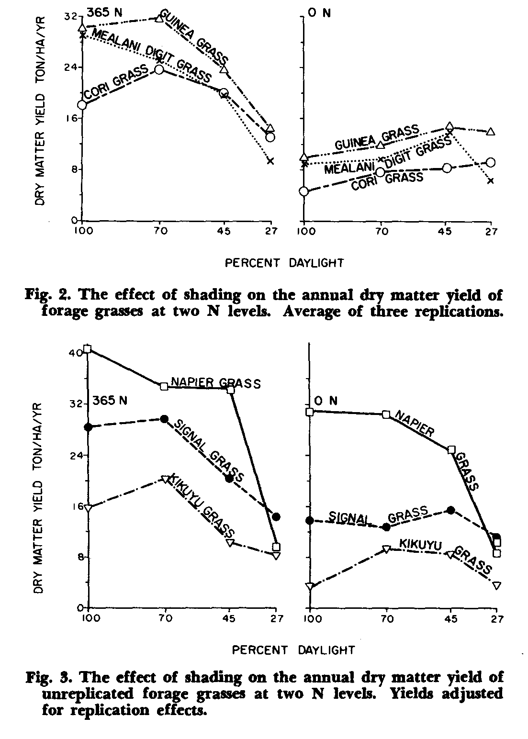
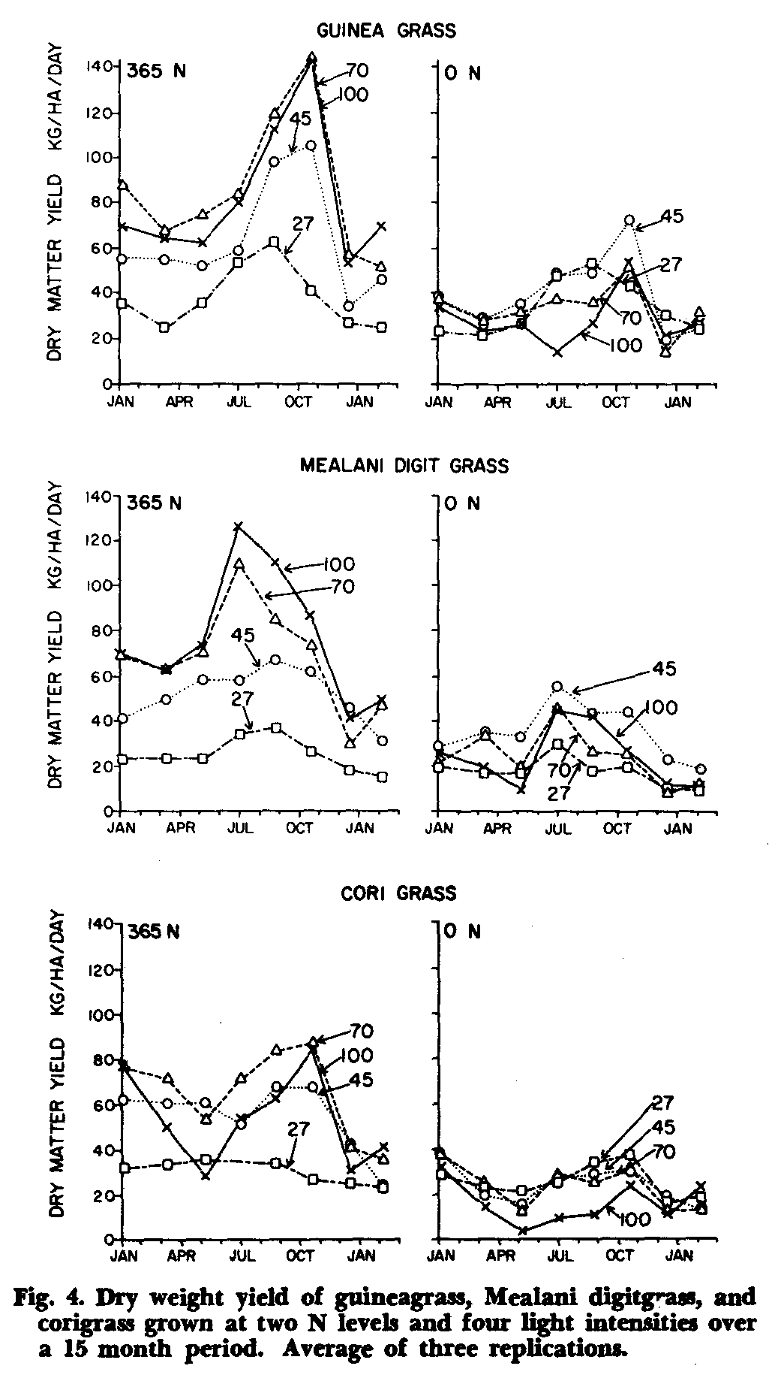
4
AGRONOMY JOURNAL, VOL. 73, MAY-JUNE 1981
(data not shown). This would seem to exclude stomatal closure (with consequent reduction in C0₂ uptake) during the hot part of the day as a factor in the lower yields in full sunlight compared to shade.
Water stress may have been a limiting factor which would explain the better growth in partial shade. Murtagh (1978) found that even well irrigated kikuyugrass was subject to water stress except in cloudy weather.
Since soils in the tropics are often low in soil N and N fertilizer is often in short supply or very expensive there may be a significant advantage for producing grass forage under shade (e.g. under coconuts or other tree crops).
The three unreplicated grasses varied greatly in their response to season: kikuyugrass was unaffected, signalgrass yields were slightly depressed during the cool season, and napiergrass yields were reduced by 50% during the cool season (data not shown).
Root weights were significantly reduced by shading at both N levels (Fig. 5), resulting in a much higher shoot:root ratio under shading. These grasses responded similarly to the tropical and temperate grasses studied by Burton et al. (1959), Deinum (1966), and Ludlow et al. (1974). The proportional root weights at 100, 70, 45, and 27% daylight were 100, 40, 26, and 9% for the fertilized and 100, 48, 21, and 10% for the unfertilized grasses, respectively. In the minus-N treatments the sum of the annual DM yields of tops plus roots were similar for all light intensities. Regrowth after harvesting was observed to be slower in the shaded plots, undoubtedly because of reduced carbohydrate reserves in the roots and stubble. We conclude that close cutting or heavy grazing of shaded pastures should be avoided, and the intervals between cutting or grazing should be longer than for pastures grown under normal daylight.
Hight et al. (1968) observed that shaded temperate forages were low in available carbohydrates. The evidence suggests that the tropical species studied here reacted similarly. Thus forage grown under shade would probably be poorly suited to fattening animals on pastures without supplementation.
Percentages of DM in the forage of all six grasses were significantly reduced by decreasing light intensity and by N fertilization (P<0.01). The average DM percentage in the forage from the minus-N plots was approximately 25% except for napiergrass which was 19%. Percentage DM was reduced by approximately 1% for every 10% reduction in light intensity. Application of N fertilizer resulted in a further reduction in DM percentage of 1 to 3% at all light intensity levels. These results agree with the results reported for orchardgrass (Dactylic glomerata (Gordon et al., 1962 and with results obtained by the authors in an earlier experiment in which guineagrass and corigrass were grown in pots within shaded enclosures. There were no significant differences in DM percentages among seasons.
The depressing effects of shading and N fertilization on DM percentage has important implications for cattle production since ruminants can only consume a fixed volume of fresh forage per day. Forage of excessively high moisture content would thus restrict nutrient intake unless digestibility was also enhanced
sufficiently to significantly increase the rate of passage through the digestive tract.

Plant Morphology
Plant height of most species increased significantly with decreasing light intensity (Table 1). Increases in height were more dramatic in the minus-N treatments where, except for napiergrass, plant heights during the cool season in the 27 and 45% light intensity treatments averaged more than double the heights in full sunlight. Kikuyugrass and signalgrass responded similarly during summer, but heights of Mealani digitgrass, corigrass, and guineagrass were less affected by shading during the summer, increasing in height by only 74, 73, and 40%, respectively. There was no significant effect on height of napiergrass in either season. Within each light intensity, average plant height of each grass was highly correlated with seasonal DM yield (low in the cool season, etc.).
The ratio of foliage area (leaves plus stems) to foliage weight provided an indirect measure of leafiness, but the leafiness index (area:weight ratio) generally increased (P<0.01) with decreasing light intensity (Table 1). The leafiness index was also slightly higher during the cool season. The values of about 100 cm²g⁻¹ measured in full daylight are in accord with data from previous experiments with kikuyugrass in Hawaii (Whitney, 1974). Leaf-plus-stem area index (LSAI) was a function of the area:weight ratio and dry weight yield, and these two factors tended to be self-cancelling. As a result, LSAI values were generally more uniform than yield. Guineagrass was significantly higher than digitgrass or corigrass, and N fertilizer more than doubled LSAI values at both warm and cool season harvests (Table 1). However light intensity affected LSAI only at the warm season harvest (30% reduction at lowest light intensity).

Percentage and Yield
The percentages of N in the dried forages of guineagrass, corigrass, and Mealani digitgrass varied inversely with yield and temperature (and hence with daylength or radiation) and were higher at reduced light intensities (Fig. 1). Forage N levels were significantly higher (P<0.01) at 27% daylight than under more intense light at all harvest dates.
Percent N was also significantly higher (by 0.10 to 0.46 percentage units) in the N-fertilized treatments
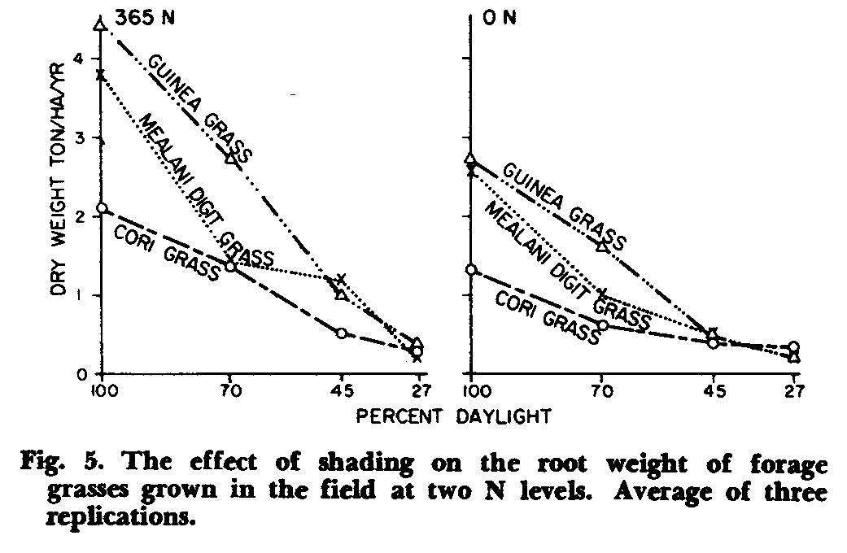
at all harvest dates. The N percentage of Mealani digitgrass was higher during the cool season than guineagrass and corigrass, but this was reversed during the summer season, resulting in similar forage N levels for all three species when averaged over the whole year. The N yields of the minus-N grasses were 2 to 3 times higher under moderate-to-heavy shade than at full daylight (Fig. 6) due in part to higher N percentage in the shaded forage. Nitrogen fertilization increased the N yield significantly for all species. Nitrogen recoveries of applied N ranged from 39 to 78% at 100 and 70% daylight, 20 to 587, at 45% daylight and only 9 to 30% at 27% daylight (Table 2). This reinforces the data for dry matter yields which indicated that N fertilization was beneficial only under conditions of adequate sunlight.
The N recovery of napiergrass at 100 and 70% daylight was lower than for the other grasses, duelargely to the very high yields of minus-N napiergrass. The reason for the high yield of minus-N napiergrass is not known, but it probably captured N from adjacent plus-N plots by virtue of its very extensive root system. Some nitrogenase activity was measured in the vicinity of napiergrass roots (see next section), but it cannot account for the very high yields of the minusN plots.

Nitrogenase Activity in Soil Core Samples
Great variability in nitrogenase activity was measured among both species and light intensities (Table 3). Nitrogenase activity of core samples during August 1976 was highest in Mealani digitgrass and kikuyugrass at 707, daylight. Slightly lower values were measured
6
AGRONOMY JOURNAL, VOL. 73, MAY-JUNE 1981
at full daylight for the same two species and for guineagrass. Nitrogenase activity was also detected in corigrass and napiergrass at 100 and 70% daylight, but signalgrass showed no detectable activity. Some activity was found at 45 and 27% daylight in Mealani digitgrass and at 45% daylight in guineagrass, with no activity measured at these low light intensities for any of the other grasses. Schank and Day (1977) also reported great variability in nitrogenase activity among species and even among varieties within the species of 30 grasses in Brazil.

Mineral Composition

With some exceptions, mineral levels in the grass top growth tended to be higher in shaded forage, higher in N-fertilized grasses (except for P and Zn) and generally higher during the cool season. The sunlight and temperature effects can be explained on the basis of dilution of nutrients by the greater yields obtained under full sun and warmer temperatures. The following discussion of individual nutrients refers to data in Table 4 (plus non-tabular data on individual species).
Phosphorus. There was a slight tendency (P=0.07) for increased P concentration with shade, especially during the summer. The major effect was N fertilization which reduced P levels to 60 to 80% of that in the minus-N treatments, apparently due to dilution of P by the heavier plus-N yields. Decreased P content with N fertilization has also been reported by Vicente-Chandler et al. (1959) and Plucknett and Fox (1965) in full daylight. There was little or no season
effect on P concentration and little variation among species.
Potassium. Potassium values increased linearly with decreasing light intensity, increasing by as much as 25 to 100% at heavy shading. This response is in agreement with the responses of temperate grasses reported earlier by Myhr and Saebo (1969) and Mayland and Grimes (1974). There was no significant effect of N fertilization or season on K concentration. The K content in napiergrass in full daylight was about double the amount measured in the other grasses. This is in general agreement with the findings by Gomide et al. (1969), although the K values found in their study were generally lower than those reported here.
Calcium and Magnesium. Shading resulted in very significant increases in both Ca and Mg concentrations, especially during the cool season when growth was further restricted. Both Ca and Mg concentrations were also increased by N fertilization (due to increased uptake of all cations). Our Ca values are comparable to those reported by Vicente-Chandler et al. (1959), Myhr and Saebo (1969), Mayland and Grimes (1974), and Whitney (1974). Also, the shading effect on Mg concentration is similar to the effects on temperate grasses reported by Burton et al. (1959) and Mayland and Grimes (1974) although their values are lower.
Sulfur. Sulfur concentrations in the forage were increased by an average of 70% by dense shade, and in some species was nearly doubled (e.g. digitgrass and corigrass). Sulfur concentrations were also higher in N-fertilized forage and in cool-season growth. There was great variability among species with kikuyugrass
ERIKSEN & WHITNEY: LIGHT INTENSITY EFFECTS ON GROWTH
433
(0.15 to 0.30%) having double the level found in napiergrass (0.07 to 0.16%).
Copper and Zinc. Shading increased the concentration of both Cu (by 60%) and Zn (by 20%). However, Cu and Zn were affected differently by N fertilization and season with Cu concentrations being increased by N fertilization (vs. Zn depression), and higher Cu levels during the warm season (vs. no effect of season for Zn). Highest Cu concentrations were found in Mealani digitgrass (6 to 10 ppm); which compares to the results of Gomide et al. (1969) who found high levels of Cu in the closely related pangolagrass. Zinc concentrations were highest in corigrass (26 to 45 ppm) and lowest in guineagrass (17 to 28 ppm).

CONCLUSIONS
In general, shading reduced dry matter yields when N fertilizer was applied, but increased yields when N was deficient. Decreasing light intensity decreased the dry matter content of the forage, but increased the N content, the levels of most minerals, plant height, and leafiness.
Thus forage quality (except for low dry matter content) and yield under N deficient conditions were best under moderate shade. This has important implications for those areas of the tropics where light intensity is low due to cloud cover or shading by trees and where N fertilization is impractical. However, such pastures should be carefully managed in order to avoid depleting root carbohydrate reserves; either by allowing long recovery intervals or by maintaining a higher-thannormal leaf area index. Further study is needed to determine the extent to which the low dry matter content (and probably low available carbohydrate level) of forage grown under shade renders it unsuitable for animals with low rumen capacity.
LITERATURE CITED
Bathurst, N. O., and K. J. Mitchell. 1958. The effect of light and temperature on the chemical composition of pasture plants. N. Z. J. Agric. Res. 1:540-552.
Blackman, G. E., and W. G. Templeman. 1938. The interaction of light intensity and nitrogen supply on the growth and metabolism of grasses and clover (Tri folium repens). Ann. Bot. N. S. 7:765-791.
Burton, G. W., J. E. Jackson, and F. E. Knox. 1959. Influence of light reduction upon the production, persistence, and chemical composition of coastal bermuda grass (Cynodon dactylon). Agron. J. 52:537-542.
Campbell, C. M., C. W. Garcia, J. C. Nolan, Y. N. Tamimi, and H. M. Ric ds. 1970. Effects har of a program for pasture fertilization in the subtropics of Hawaii. West. Sec. Amer. Soc. Anim. Sci. Proc. 21:297-302.
Cunningham, R. K., and K. F. Nielsen. 1965. Cation-anion relationships in crop nutrition. The effects of soil temperature, light and soil water tension. J. Agric. Sci. 64:379-386.
Davis, R. G., G. M. Robertson, W. C. Johnson, and A. F. Wiese. 1966. A modified optical planimeter for measuring leaf area. Agron. J. 58:106-107.
Deinum, B. 1966. Climate, nitrogen, and grass. Research into the influence of light intensity, water supply, and nitrogen on the production and chemical composition of grass. Meded. Landbouwhogesch. Wageningen. 66 (11). 91 p.
Earley, E. B., R. J. Miller, G. L. Reichert, R. H. Hageman, and R. D. Seif. 1966. Effects of shade on maize production under field conditions. Crop Sci. 6:1-7.
Federer, W. T., and D. Raghavarao. 1975. On augmented designs. Biometrics 31:29-35.
Gomide, J. A., C. H. Noller, G. O. Mott. J. H. Conrad, and D. L. Hill. 1969. Mineral composition o six tropical grasses as influenced by plant age and nitrogen fertilization. Agron. J. 61:120-123.
Gordon, C. H., A. M. Decker, and H. G. Wiseman. 1962. Some effects of nitrogen fertilizer, maturity and light on the composition of orchardgrass. Agron. J. 54:376-378.
Grof, B., and W. A. T. Harding. 1970. Dry matter yields and animal production of guineagrass (Panicum maximum) on the humid tropical coast of North Queensland. Trop. Grasslands 4:85-95.
Hight, G. K., D. P. Sinclair, and R. J. Lancaster. 1968. Some effects of shading and of nitrogen fertilizer on the chemical composition of freeze-dried and oven-dried herbage and on the nutritive value of oven-dried herbage fed to sheep. N. Z. J. Agric. Res. 11:286-302.
Hugh, E. I. 1972. Regional seminar on pastures and cattle under coconuts. Western Samao, 30 Aug.-12 Sept. South Pac. Comm., Noumea, New Caledonia. 156 p.
Javier, E. Q. 1974. Improved varieties for pastures under coconuts. Extn. Bull. No. 37. ASPAC, FFTC.
Ludlow, M. M., G. L. Wilson, and M. R. Heslehurst. 1974. Stu-dies on the productivity of tropical pasture plants. Effect of shading on growth, photosynthesis and respiration in two grasses and two legumes. Austr. J. Agric. Res. 25:425-433.
Mayland, H. F., and D. L. Grunes. 1974. Shade induced grass-tetany-prone chemical changes in Agropyron desertorum and Elymus cinereus. J. Range Mgmt. 27:198-201. Murtagh, G. J. 1978. The effect of evaporative demand on the growth of well-watered kikuyu. Agric. Meteor. 19:379389.
Myhr, K., and S. Saebo. 1969. Verknaden av skygging pd vekst, utvikling og kjemisk samansetning hos nokre grasarter. (The effects on shade of growth, development and chemical composition in some grass species). Forsk. Fors. Landon 20:297315.
Ng, T. T., and T. H. Wong. 1976. Comparative productivity of two tropical grasses as influenced by fertilizer nitrogen and pasture legumes. Trop. Grassld. 10:179-185.
Olsen, F. J. 1972. Effect of large applications of nitrogen fertilizer on the productivity and protein content of four tropical grasses in Uganda. Trop. Agric. (Trinidad). 49:251-259. Paulsen, G. M., and D. Smith. 1969. Organic reserves, axillary bud activity, and herbage yields of smooth bromegrass as influenced by time of cutting, nitrogen fertilization, and shading. Crop Sci. 9:529-534.
Plucknett, D. L., and R. L. Fox. 1965. Effects of phosphorus fertilization on yields and composition of pangolagrass and Desmodium intortum. Proc. 9th Int. Grassld. Cong:1525-1529. Pyon, J. Y. 1975. Studies on the biology of sourgrass (Trichachne insu aris (L.) Nees) and its competition with buffelgrass (Cenchrus ciliaris L.) and guineagrass (Panicum maximum Jacq.) Ph.D. Dissertation. Univ. of Hawaii. Univ. Microfilms. Ann Arbor, Mich. Diss. Abstr. 76:16505.
Schanh, S. C., and J. M. Day. 1977. Nitrogenase activity, nitrogen content, in vitro digestibility and yield of 30 tropical forage grasses in Brazil. Trop. Agric. (Trinidad). 54:119-125. Tamimi, Y. N., L. B. Sherrod, S. M. Ishizaki, and T. Izuno. 1968. The effect of levels of nitrogen, phosphorus, and potassium fertilization upon beef production on kikuyugrass. Hawaii Agric. Exp. Tech. Bull. No. 76.
Vicente-Chandler, J., F. Abruna, R. Caro-Costas, J. Figarella, S. Silva, and R. W. Pearson. 1959. Intensive grassland management in the humid tropics of Puerto Rico. Bull. 233. Univ. Puerto Rico, Mayaguez Campus, Rio Piedras, Puerto Rico. 163 p.
Whitney, A. S. 1970. Effects of harvesting interval, height of cut, and nitrogen fertilization on the performance of Desmodium intortum mixtures in Hawaii. Proc. 11th Int. Grassld. Cong: 631-636.
1974. Growth of kikuyugrass (Pennisetum clandestinum) under clipping. I. Effects of nitrogen fertilization, cutting interval, and season on yields and forage characteristics. Agron. J. 66:281-287.
Yoshihara, T., and P. C. Ekern. 1977. Solar radiation measurements in Hawaii. Hawaii Nat. Energy Inst. Univ. of Hawaii. 43 p.

